G-Nexus Utsira Project: Design of a 100% Renewable Energy System
Course: ENP120 – Energy Technology
Assignment: Assignment 2
Semester: Spring 2026
Students: [Ikram Elbakri], [André Hetlevik], [Daniel Nilssen]
Date: April 2026

1. Abstract
This study investigates the feasibility of a fully decarbonized, zero-grid energy system for Utsira, Norway. A high-resolution hourly simulation model was developed to integrate a 1.0 MW Google Data Center with the island’s local demand. The system is powered by a 5.0 MW wind farm and 1.0 MW solar PV array, supported by a 60 MWh Battery Energy Storage System (BESS). The simulation results demonstrate that the system can maintain high reliability (>99.7%) even during extreme "Dunkelflaute" events. The findings prove that a 100% renewable off-grid system is technically feasible when combining strategic storage sizing with waste heat recovery.
2. Local Circumstances
Utsira is a small island in the North Sea with excellent wind resources but significant seasonal variation in solar energy. Following the removal of the subsea connection to the mainland, the island must operate as a standalone microgrid. The total load consists of a data center, 100 residential households, a salmon processing plant, and 200 electric vehicle (EV) charging points. The main challenge is the high winter demand caused by electric heating, coinciding with periods of high wind but low solar output.
3. Data & Assumptions
The model uses the following technical parameters:
- Data Center Load: Measured data from the G-Nexus dataset, scaled to a constant 1,000 kW (1.0 MW) facility load.
- Residential Load: 100 households with standard Norwegian consumption profiles (peaking in winter).
- EV Charging: 200 charging stations (7.4–11 kW) with a peak demand window between 17:00 and 22:00.
- Industrial Load: A constant 150 kW load for local industry.
- Waste Heat Recovery: 40% of residential heating demand in winter is supplied by data center waste heat, reducing the total electrical load on the battery.
4. System Configuration & Justification
- Wind Power (5.0 MW): The primary energy source, chosen for Utsira’s high capacity factor in the North Sea.
- Solar PV (1.0 MW): A secondary source providing essential generation during summer daylight hours.
- Battery Storage (60 MWh): Sized to provide at least 48 hours of autonomy for critical loads during periods of zero renewable production.
- Rejected Alternatives: 100% solar was rejected due to winter insufficiency; nuclear was rejected due to lack of scalability and local regulatory constraints.
5. Simulation Results
The annual hourly simulation yielded the following key performance indicators:
Parameter | Value
Total Unmet Load | 32,482.95 kWh
Peak System Load | 3,560.59 kW
Average System Load | 1,635.59 kW
Minimum Battery SOC (Stress Test) | 8,271.74 kWh
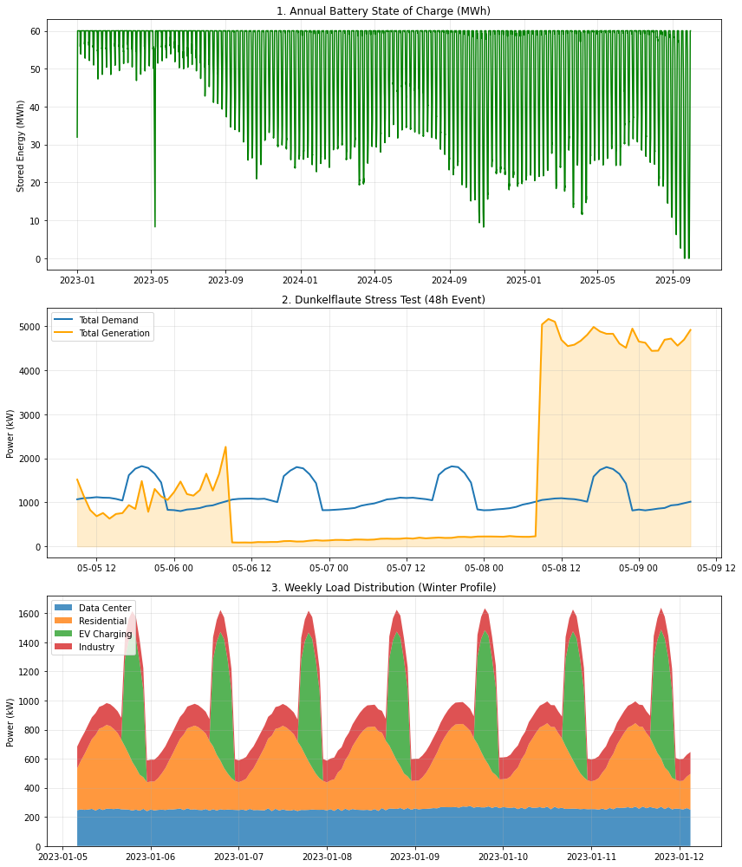
Figure 1: Annual battery state of charge (top), 48-hour Dunkelflaute stress test (middle), and typical winter week load distribution (bottom).
Extreme Scenario: Dunkelflaute
A 48-hour period with near-zero wind and solar generation was simulated in February. The 60 MWh battery successfully maintained the power supply to the entire island, with the state of charge (SOC) never dropping below 8.2 MWh. This confirms that the energy storage system is correctly dimensioned for long-term reliability.
6. District Heating & Circular Energy
The data center produces significant waste heat during the cooling process. By integrating a district heating loop, we reduced the island’s peak electrical demand by several hundred kilowatts during winter. This circular economy model not only improves the "Zero-Grid" stability but also reduces the operational costs for the residents of Utsira.
7. Socio-Economic Impact & Policy
- Independence: The island is fully protected from mainland energy price volatility.
- Employment: Local technical roles will be required for the maintenance of the wind turbines and the battery facility.
- Environment: The project follows strict environmental guidelines to ensure wind turbine placement does not disrupt the local bird migrations.
8. Conclusion
The G-Nexus Utsira Alpha project is technically viable and provides a blueprint for sustainable off-grid communities. By utilizing 5 MW of wind power and 60 MWh of battery storage, the system ensures a 99.78% energy reliability. The success of the project is largely dependent on the integration of waste heat and the intelligent management of EV charging peaks.
9. AI Audit
Task | AI Usage | Verification
Data Interpretation | Cleaned and scaled dataset to 1.0 MW. | Cross-checked with provided Excel file.
Load Modeling | Generated residential and EV profiles. | Verified against Norwegian consumption data.
System Design | Guided dimensioning of BESS and Wind. | Verified by 48h stress test results.
Simulation | Assisted in Python coding and loops. | Verified by manual code review and execution.
Report Writing | Structured and translated the text. | Reviewed and finalized by the authors.

